Connect to your Linux instance using Session Manager

Session Manager is a fully managed AWS Systems Manager capability that lets you manage your Amazon EC2 instances through an interactive one-click browser-based shell or through the AWS CLI. You can use Session Manager to start a session with an instance in your account. After the session is started, you can run bash commands as you would through any other connection type.

Create an IAM instance profile for Systems Manager

Navigate to the Identity and Access Management (IAM)console .

In the left navigation pane, select Roles under Access management. Then select Create role. 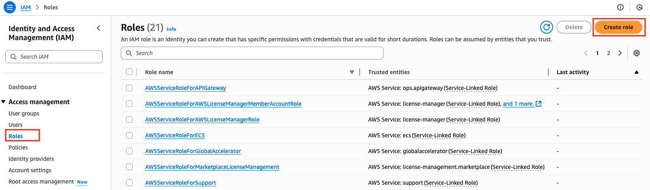

In Select trusted entity, under Trusted entity type, choose AWS service. Choose EC2 from the dropdown menu in Service or use case. Then select EC2 as the use case and click Next..
On the Add permissions page, use the Search field to locate the AmazonSSMManagedInstanceCore permission policy. Select the box next to its name, then choose Next. 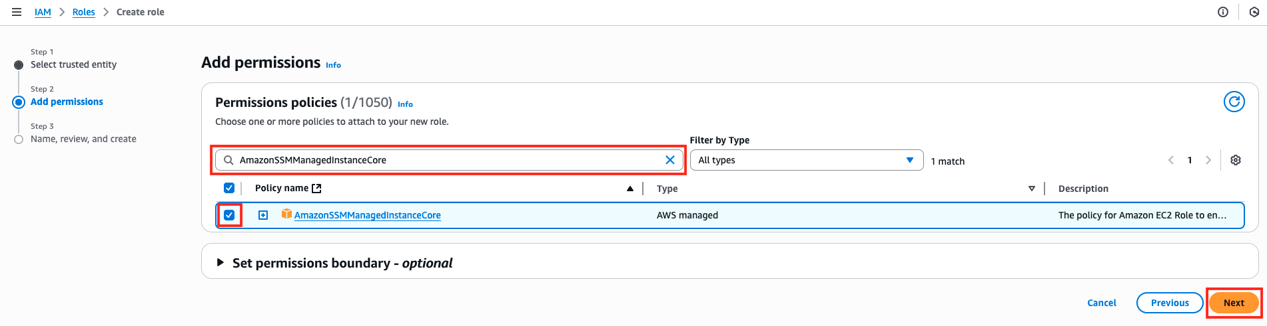
For Role name, type SSMInstanceProfile. Leave other values as default and select Create role. 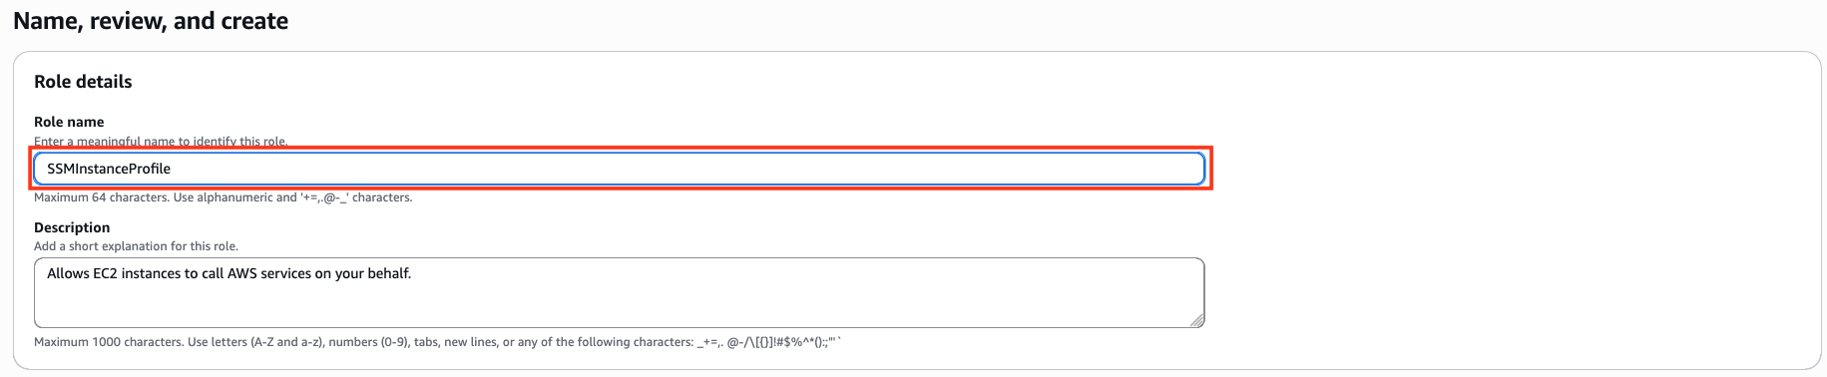

Make a note of the role name. You will use this role when you create new instances that you want to manage by using Systems Manager.

Attach the Systems Manager instance profile to an existing instance (console)

Navigate to the Amazon EC2 console .

In the navigation pane, under Instances, choose Instances. Then choose your EC2 instance from the list.

Click Actions in the top menu, select Security and choose Modify IAM role. 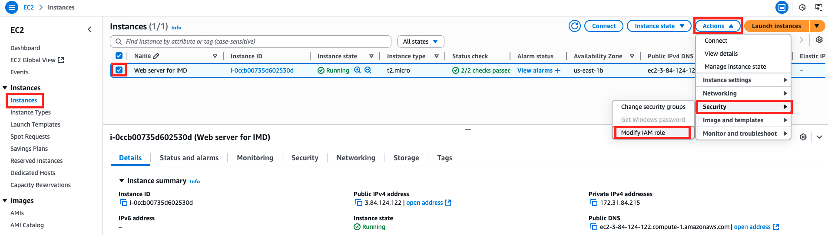

For IAM role, choose the instance profile you created SSMInstanceProfile.

Select Update IAM role. 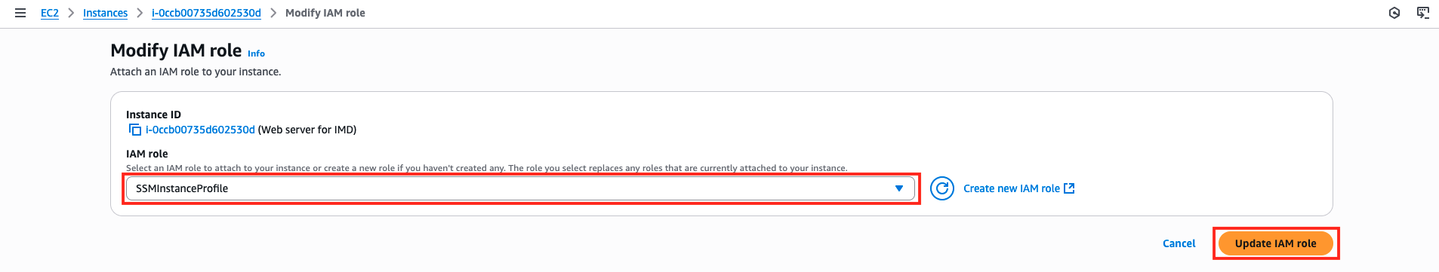

Connect to your Linux instance using Session Manager

In the EC2 instance console, select the instance you want to connect to, and then click the Connect button. 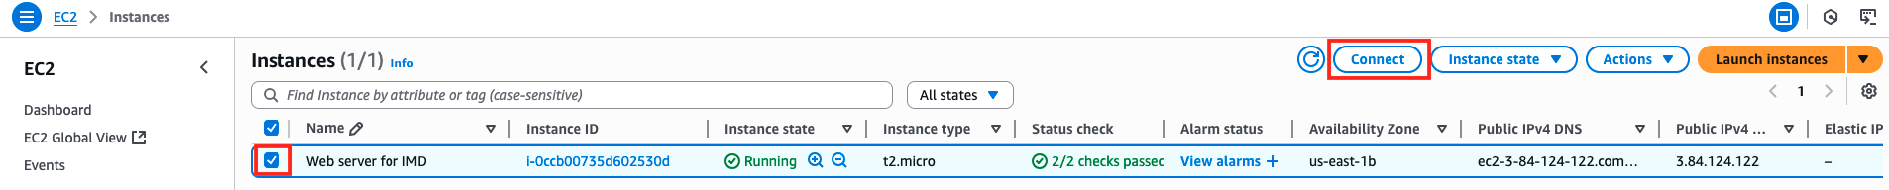
In the Connect page, select Session Manager.
Review the Session Manager usage section to know the advantages of using Session Manager.
Select Connect.

If you are not able to connect, wait a few seconds and refresh your browser. The EC2 instance is being prepared for Session Manager access
A new session will start in a new tab. When the session starts in a new browser tab, you can run bash commands just like in a standard terminal connection. 